Using Korean test images (small)

true positives = 11  
true negatives = 43  
false positives = 48  
false negatives = 31  
not confident of any answer = 20  
total = 153  
  
sensitivity = 0.2619  
specificity = 0.4725  
precision = 0.1864  
recall = 0.2619  
  
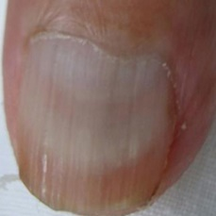normal#25 **Confidences:**normal = 7%; fungal = 0%; warrants second opinion = 93%;   
It is most likely that the nail indicates something that warrants a second opinion and you should seek medical advice. (Confidence score is 93%)  
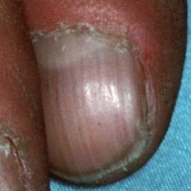normal#31 **Confidences:**normal = 7%; fungal = 0%; warrants second opinion = 93%;   
It is most likely that the nail indicates something that warrants a second opinion and you should seek medical advice. (Confidence score is 93%)  
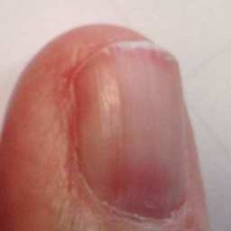normal#20 **Confidences:**normal = 7%; fungal = 0%; warrants second opinion = 93%;   
It is most likely that the nail indicates something that warrants a second opinion and you should seek medical advice. (Confidence score is 93%)  
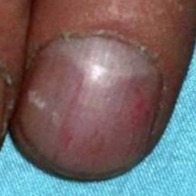normal#32 **Confidences:**normal = 11%; fungal = 2%; warrants second opinion = 87%;   
It is most likely that the nail indicates something that warrants a second opinion and you should seek medical advice. (Confidence score is 87%)  
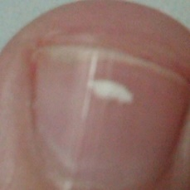normal#24 **Confidences:**normal = 15%; fungal = 7%; warrants second opinion = 78%;   
It is most likely that the nail indicates something that warrants a second opinion and you should seek medical advice. (Confidence score is 78%)  
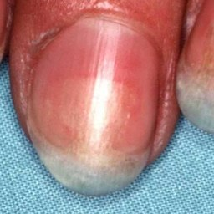normal#6 **Confidences:**normal = 20%; fungal = 1%; warrants second opinion = 80%;   
It is most likely that the nail indicates something that warrants a second opinion and you should seek medical advice. (Confidence score is 80%)  
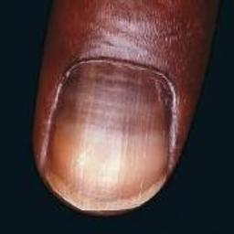normal#30 **Confidences:**normal = 52%; fungal = 2%; warrants second opinion = 46%;   
Not very sure whether the nail is OK or not. Sorry.  
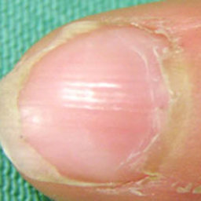normal#42 **Confidences:**normal = 54%; fungal = 0%; warrants second opinion = 46%;   
Not very sure whether the nail is OK or not. Sorry.  
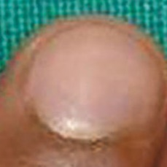normal#34 **Confidences:**normal = 57%; fungal = 1%; warrants second opinion = 42%;   
Not very sure whether the nail is OK or not. Sorry.  
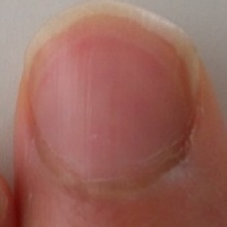normal#40 **Confidences:**normal = 61%; fungal = 0%; warrants second opinion = 39%;   
It might be warrant a second opinion (confidence score is 39%)   
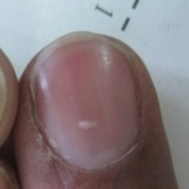normal#12 **Confidences:**normal = 62%; fungal = 0%; warrants second opinion = 38%;   
It might be warrant a second opinion (confidence score is 38%)   
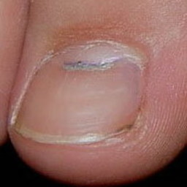normal#16 **Confidences:**normal = 65%; fungal = 1%; warrants second opinion = 34%;   
It might be warrant a second opinion (confidence score is 34%)   
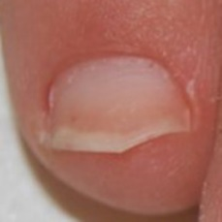normal#1 **Confidences:**normal = 72%; fungal = 4%; warrants second opinion = 25%;   
It might be warrant a second opinion (confidence score is 25%)   
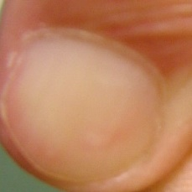normal#10 **Confidences:**normal = 75%; fungal = 0%; warrants second opinion = 25%;   
It might be warrant a second opinion (confidence score is 25%)   
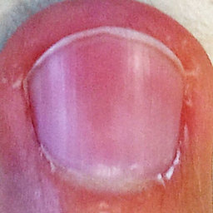normal#11 **Confidences:**normal = 76%; fungal = 0%; warrants second opinion = 24%;   
It might be warrant a second opinion (confidence score is 24%)   
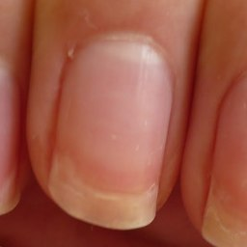normal#47 **Confidences:**normal = 76%; fungal = 0%; warrants second opinion = 24%;   
It might be warrant a second opinion (confidence score is 24%)   
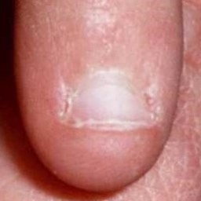normal#38 **Confidences:**normal = 77%; fungal = 2%; warrants second opinion = 20%;   
It might be warrant a second opinion (confidence score is 20%)   
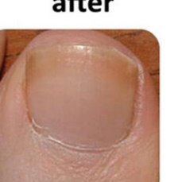normal#33 **Confidences:**normal = 78%; fungal = 6%; warrants second opinion = 16%;   
The nail's condition is normal with confidence score of 78%. The confidence score for it being warranting a second opinion is 16%.  
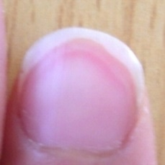normal#44 **Confidences:**normal = 78%; fungal = 0%; warrants second opinion = 22%;   
It might be warrant a second opinion (confidence score is 22%)   
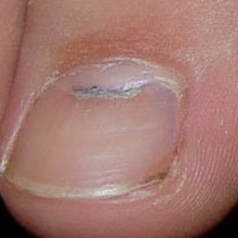normal#3 **Confidences:**normal = 82%; fungal = 0%; warrants second opinion = 18%;   
The nail's condition is normal with confidence score of 82%. The confidence score for it being warranting a second opinion is 18%.  
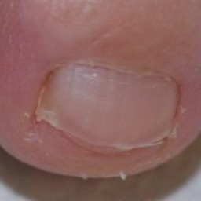normal#35 **Confidences:**normal = 85%; fungal = 0%; warrants second opinion = 14%;   
The nail's condition is normal with confidence score of 85%. The confidence score for it being warranting a second opinion is 14%.  
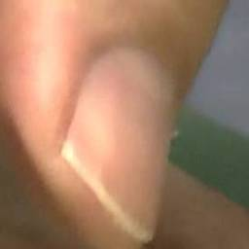normal#41 **Confidences:**normal = 86%; fungal = 10%; warrants second opinion = 4%;   
The nail's condition is normal with confidence score of 86%. Otherwise it is fungal with confidence score of 10%.  
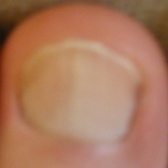normal#43 **Confidences:**normal = 87%; fungal = 2%; warrants second opinion = 10%;   
The nail's condition is normal with confidence score of 87%. The confidence score for it being warranting a second opinion is 10%.  
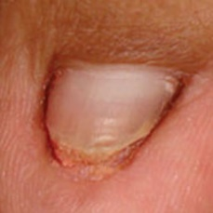normal#28 **Confidences:**normal = 89%; fungal = 3%; warrants second opinion = 8%;   
The nail's condition is normal with confidence score of 89%. The confidence score for it being warranting a second opinion is 8%.  
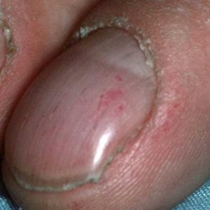normal#23 **Confidences:**normal = 90%; fungal = 3%; warrants second opinion = 7%;   
The nail's condition is normal with confidence score of 90%. The confidence score for it being warranting a second opinion is 7%.  
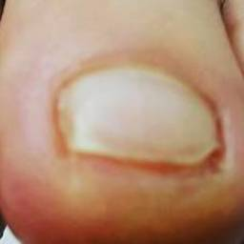normal#49 **Confidences:**normal = 91%; fungal = 1%; warrants second opinion = 8%;   
The nail's condition is normal with confidence score of 91%. The confidence score for it being warranting a second opinion is 8%.  
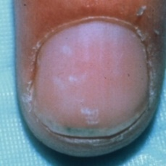normal#26 **Confidences:**normal = 92%; fungal = 0%; warrants second opinion = 8%;   
The nail's condition is normal with confidence score of 92%. The confidence score for it being warranting a second opinion is 8%.  
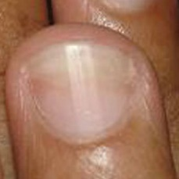normal#9 **Confidences:**normal = 92%; fungal = 1%; warrants second opinion = 7%;   
The nail's condition is normal with confidence score of 92%. The confidence score for it being warranting a second opinion is 7%.  
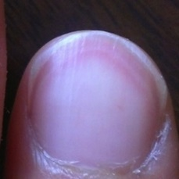normal#46 **Confidences:**normal = 92%; fungal = 1%; warrants second opinion = 7%;   
The nail's condition is normal with confidence score of 92%. The confidence score for it being warranting a second opinion is 7%.  
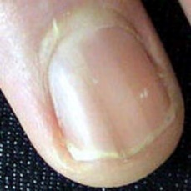normal#37 **Confidences:**normal = 92%; fungal = 0%; warrants second opinion = 8%;   
The nail's condition is normal with confidence score of 92%. The confidence score for it being warranting a second opinion is 8%.  
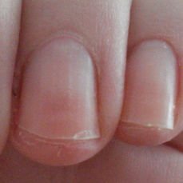normal#29 **Confidences:**normal = 93%; fungal = 1%; warrants second opinion = 6%;   
The nail's condition is normal with confidence score of 93%. The confidence score for it being warranting a second opinion is 6%.  
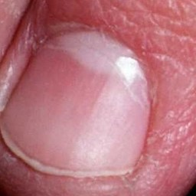normal#2 **Confidences:**normal = 93%; fungal = 0%; warrants second opinion = 6%;   
The nail's condition is normal with confidence score of 93%. The confidence score for it being warranting a second opinion is 6%.  
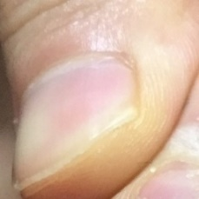normal#48 **Confidences:**normal = 95%; fungal = 0%; warrants second opinion = 5%;   
The nail's condition is normal with confidence score of 95%. The confidence score for it being warranting a second opinion is 5%.  
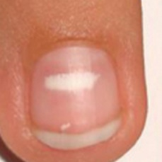normal#39 **Confidences:**normal = 95%; fungal = 1%; warrants second opinion = 4%;   
The nail's condition is normal with confidence score of 95%. The confidence score for it being warranting a second opinion is 4%.  
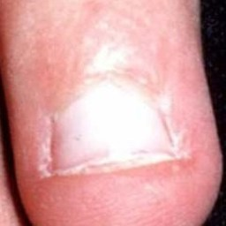normal#17 **Confidences:**normal = 96%; fungal = 2%; warrants second opinion = 2%;   
The nail's condition is normal with confidence score of 96%. Otherwise it is fungal with confidence score of 2%.  
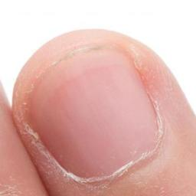normal#22 **Confidences:**normal = 96%; fungal = 0%; warrants second opinion = 4%;   
The nail's condition is normal with confidence score of 96%. The confidence score for it being warranting a second opinion is 4%.  
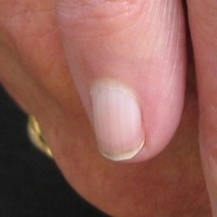normal#14 **Confidences:**normal = 96%; fungal = 2%; warrants second opinion = 2%;   
The nail's condition is normal with confidence score of 96%. Otherwise it is fungal with confidence score of 2%.  
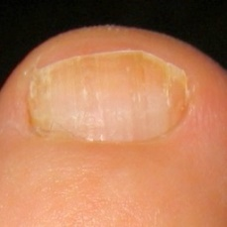normal#27 **Confidences:**normal = 96%; fungal = 2%; warrants second opinion = 2%;   
The nail's condition is normal with confidence score of 96%. Otherwise it is fungal with confidence score of 2%.  
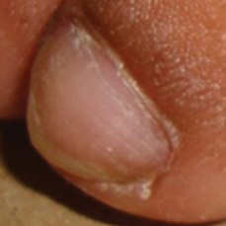normal#18 **Confidences:**normal = 97%; fungal = 1%; warrants second opinion = 2%;   
The nail's condition is normal with confidence score of 97%. The confidence score for it being warranting a second opinion is 2%.  
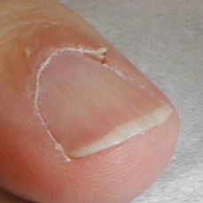normal#8 **Confidences:**normal = 97%; fungal = 0%; warrants second opinion = 3%;   
The nail's condition is normal with confidence score of 97%. The confidence score for it being warranting a second opinion is 3%.  
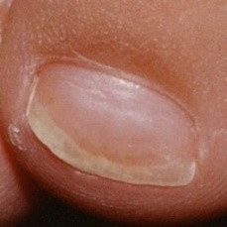normal#4 **Confidences:**normal = 98%; fungal = 1%; warrants second opinion = 1%;   
The nail's condition is normal with confidence score of 98%. Otherwise it is fungal with confidence score of 1%.  
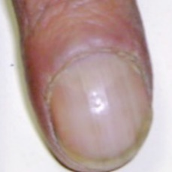normal#13 **Confidences:**normal = 98%; fungal = 0%; warrants second opinion = 2%;   
The nail's condition is normal with confidence score of 98%. The confidence score for it being warranting a second opinion is 2%.  
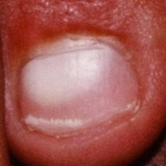normal#36 **Confidences:**normal = 98%; fungal = 1%; warrants second opinion = 1%;   
The nail's condition is normal with confidence score of 98%. Otherwise it is fungal with confidence score of 1%.  
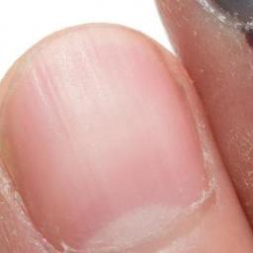normal#7 **Confidences:**normal = 98%; fungal = 0%; warrants second opinion = 2%;   
The nail's condition is normal with confidence score of 98%. The confidence score for it being warranting a second opinion is 2%.  
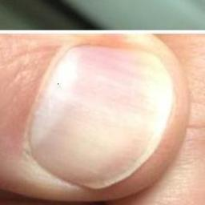normal#5 **Confidences:**normal = 98%; fungal = 0%; warrants second opinion = 2%;   
The nail's condition is normal with confidence score of 98%. The confidence score for it being warranting a second opinion is 2%.  
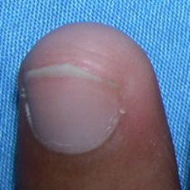normal#19 **Confidences:**normal = 98%; fungal = 0%; warrants second opinion = 1%;   
The nail's condition is normal with confidence score of 98%. The confidence score for it being warranting a second opinion is 1%.  
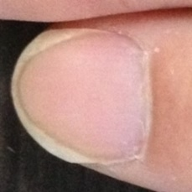normal#45 **Confidences:**normal = 98%; fungal = 0%; warrants second opinion = 1%;   
The nail's condition is normal with confidence score of 98%. The confidence score for it being warranting a second opinion is 1%.  
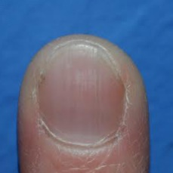normal#15 **Confidences:**normal = 99%; fungal = 0%; warrants second opinion = 1%;   
The nail's condition is normal with confidence score of 99%. The confidence score for it being warranting a second opinion is 1%.  
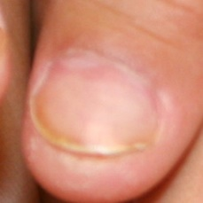normal#21 **Confidences:**normal = 99%; fungal = 0%; warrants second opinion = 0%;   
The nail's condition is normal with confidence score of 99%.  
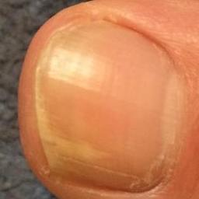fungal#8 **Confidences:**normal = 65%; fungal = 0%; warrants second opinion = 35%;   
It might be warrant a second opinion (confidence score is 35%)   
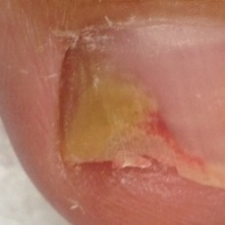fungal#6 **Confidences:**normal = 44%; fungal = 0%; warrants second opinion = 55%;   
Not very sure whether the nail is OK or not. Sorry.  
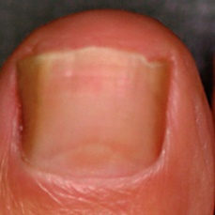fungal#11 **Confidences:**normal = 35%; fungal = 0%; warrants second opinion = 65%;   
It is most likely that the nail indicates something that warrants a second opinion and you should seek medical advice. (Confidence score is 65%)  
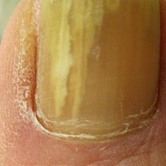fungal#25 **Confidences:**normal = 88%; fungal = 0%; warrants second opinion = 12%;   
The nail's condition is normal with confidence score of 88%. The confidence score for it being warranting a second opinion is 12%.  
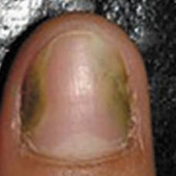fungal#16 **Confidences:**normal = 29%; fungal = 0%; warrants second opinion = 71%;   
It is most likely that the nail indicates something that warrants a second opinion and you should seek medical advice. (Confidence score is 71%)  
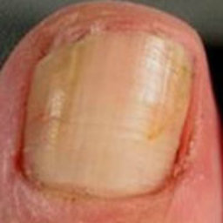fungal#3 **Confidences:**normal = 13%; fungal = 0%; warrants second opinion = 86%;   
It is most likely that the nail indicates something that warrants a second opinion and you should seek medical advice. (Confidence score is 86%)  
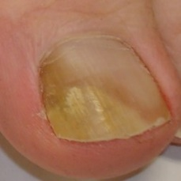fungal#27 **Confidences:**normal = 80%; fungal = 1%; warrants second opinion = 19%;   
The nail's condition is normal with confidence score of 80%. The confidence score for it being warranting a second opinion is 19%.  
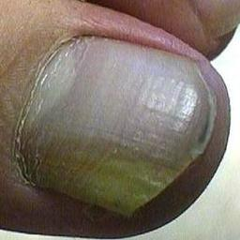fungal#19 **Confidences:**normal = 68%; fungal = 1%; warrants second opinion = 32%;   
It might be warrant a second opinion (confidence score is 32%)   
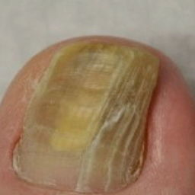fungal#30 **Confidences:**normal = 12%; fungal = 1%; warrants second opinion = 87%;   
It is most likely that the nail indicates something that warrants a second opinion and you should seek medical advice. (Confidence score is 87%)  
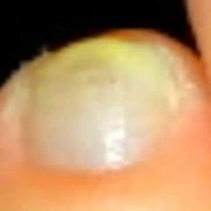fungal#38 **Confidences:**normal = 70%; fungal = 2%; warrants second opinion = 29%;   
It might be warrant a second opinion (confidence score is 29%)   
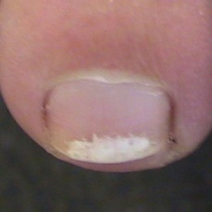fungal#5 **Confidences:**normal = 98%; fungal = 2%; warrants second opinion = 0%;   
The nail's condition is normal with confidence score of 98%. Otherwise it is fungal with confidence score of 2%.  
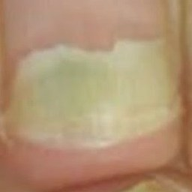fungal#44 **Confidences:**normal = 5%; fungal = 2%; warrants second opinion = 93%;   
It is most likely that the nail indicates something that warrants a second opinion and you should seek medical advice. (Confidence score is 93%)  
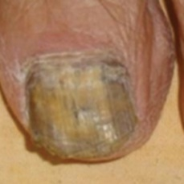fungal#31 **Confidences:**normal = 38%; fungal = 2%; warrants second opinion = 60%;   
It is most likely that the nail indicates something that warrants a second opinion and you should seek medical advice. (Confidence score is 60%)  
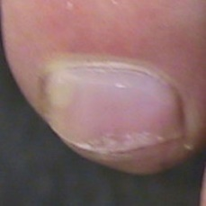fungal#23 **Confidences:**normal = 95%; fungal = 2%; warrants second opinion = 3%;   
The nail's condition is normal with confidence score of 95%. The confidence score for it being warranting a second opinion is 3%.  
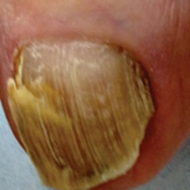fungal#15 **Confidences:**normal = 63%; fungal = 2%; warrants second opinion = 35%;   
It might be warrant a second opinion (confidence score is 35%)   
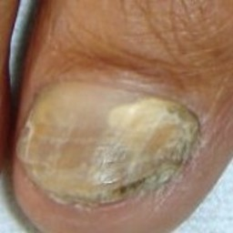fungal#1 **Confidences:**normal = 94%; fungal = 3%; warrants second opinion = 3%;   
The nail's condition is normal with confidence score of 94%. Otherwise it is fungal with confidence score of 3%.  
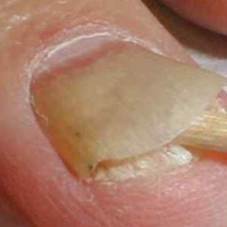fungal#4 **Confidences:**normal = 82%; fungal = 3%; warrants second opinion = 15%;   
The nail's condition is normal with confidence score of 82%. The confidence score for it being warranting a second opinion is 15%.  
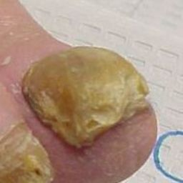fungal#33 **Confidences:**normal = 15%; fungal = 4%; warrants second opinion = 81%;   
It is most likely that the nail indicates something that warrants a second opinion and you should seek medical advice. (Confidence score is 81%)  
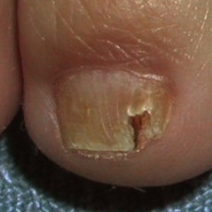fungal#21 **Confidences:**normal = 58%; fungal = 4%; warrants second opinion = 38%;   
Not very sure whether the nail is OK or not. Sorry.  
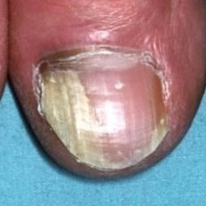fungal#22 **Confidences:**normal = 54%; fungal = 4%; warrants second opinion = 42%;   
Not very sure whether the nail is OK or not. Sorry.  
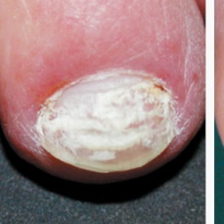fungal#46 **Confidences:**normal = 95%; fungal = 5%; warrants second opinion = 0%;   
The nail's condition is normal with confidence score of 95%. Otherwise it is fungal with confidence score of 5%.  
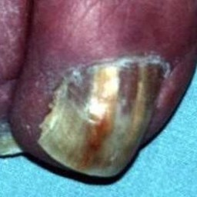fungal#29 **Confidences:**normal = 6%; fungal = 5%; warrants second opinion = 89%;   
It is most likely that the nail indicates something that warrants a second opinion and you should seek medical advice. (Confidence score is 89%)  
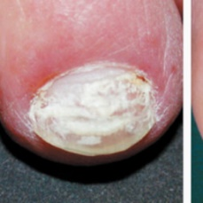fungal#51 **Confidences:**normal = 95%; fungal = 5%; warrants second opinion = 0%;   
The nail's condition is normal with confidence score of 95%. Otherwise it is fungal with confidence score of 5%.  
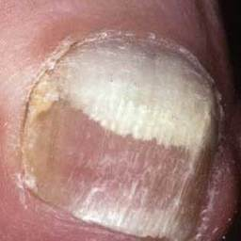fungal#32 **Confidences:**normal = 63%; fungal = 5%; warrants second opinion = 32%;   
It might be warrant a second opinion (confidence score is 32%)   
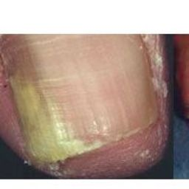fungal#14 **Confidences:**normal = 56%; fungal = 7%; warrants second opinion = 37%;   
Not very sure whether the nail is OK or not. Sorry.  
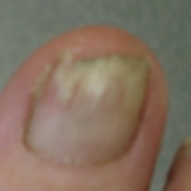fungal#52 **Confidences:**normal = 88%; fungal = 8%; warrants second opinion = 4%;   
The nail's condition is normal with confidence score of 88%. Otherwise it is fungal with confidence score of 8%.  
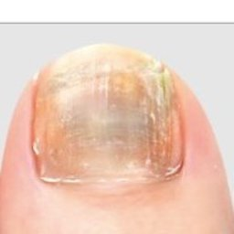fungal#37 **Confidences:**normal = 58%; fungal = 8%; warrants second opinion = 34%;   
Not very sure whether the nail is OK or not. Sorry.  
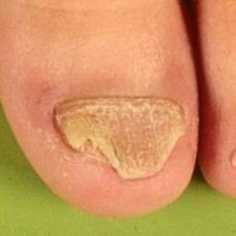fungal#0 **Confidences:**normal = 81%; fungal = 8%; warrants second opinion = 11%;   
The nail's condition is normal with confidence score of 81%. The confidence score for it being warranting a second opinion is 11%.  
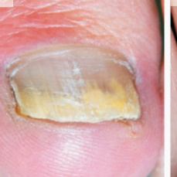fungal#50 **Confidences:**normal = 90%; fungal = 8%; warrants second opinion = 2%;   
The nail's condition is normal with confidence score of 90%. Otherwise it is fungal with confidence score of 8%.  
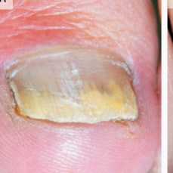fungal#47 **Confidences:**normal = 85%; fungal = 12%; warrants second opinion = 3%;   
The nail's condition is normal with confidence score of 85%. Otherwise it is fungal with confidence score of 12%.  
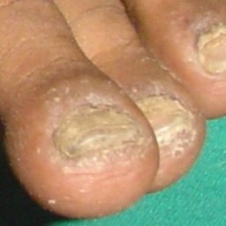fungal#26 **Confidences:**normal = 84%; fungal = 15%; warrants second opinion = 1%;   
The nail's condition is normal with confidence score of 84%. Otherwise it is fungal with confidence score of 15%.  
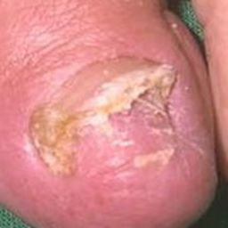fungal#7 **Confidences:**normal = 74%; fungal = 22%; warrants second opinion = 4%;   
The nail's condition is normal with confidence score of 74%. Otherwise it is fungal with confidence score of 22%.  
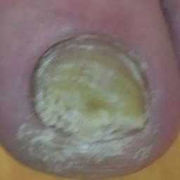fungal#24 **Confidences:**normal = 74%; fungal = 24%; warrants second opinion = 2%;   
The nail's condition is normal with confidence score of 74%. Otherwise it is fungal with confidence score of 24%.  
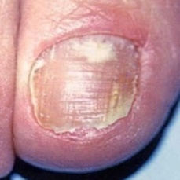fungal#12 **Confidences:**normal = 69%; fungal = 27%; warrants second opinion = 4%;   
The nail's condition is normal with confidence score of 69%. Otherwise it is fungal with confidence score of 27%.  
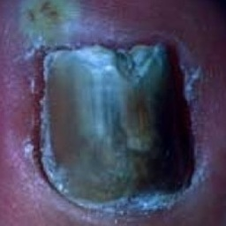fungal#2 **Confidences:**normal = 3%; fungal = 28%; warrants second opinion = 69%;   
It is most likely that the nail indicates something that warrants a second opinion and you should seek medical advice. (Confidence score is 69%)  
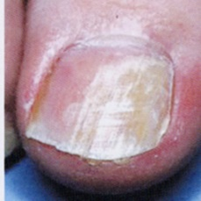fungal#48 **Confidences:**normal = 64%; fungal = 34%; warrants second opinion = 2%;   
The nail's condition is normal with confidence score of 64%. Otherwise it is fungal with confidence score of 34%.  
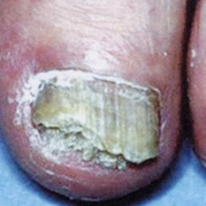fungal#49 **Confidences:**normal = 49%; fungal = 35%; warrants second opinion = 15%;   
Not very sure whether the nail is OK or not. Sorry.  
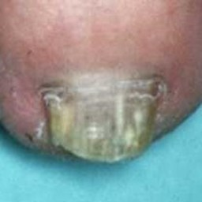fungal#34 **Confidences:**normal = 21%; fungal = 38%; warrants second opinion = 41%;   
Not very sure whether the nail is OK or not. Sorry.  
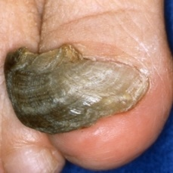fungal#36 **Confidences:**normal = 56%; fungal = 41%; warrants second opinion = 4%;   
Not very sure whether the nail is OK or not. Sorry.  
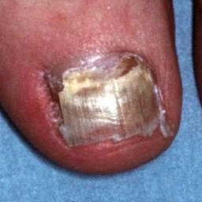fungal#13 **Confidences:**normal = 2%; fungal = 43%; warrants second opinion = 56%;   
Not very sure whether the nail is OK or not. Sorry.  
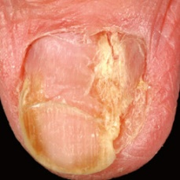fungal#17 **Confidences:**normal = 51%; fungal = 46%; warrants second opinion = 4%;   
Not very sure whether the nail is OK or not. Sorry.  
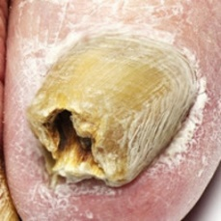fungal#45 **Confidences:**normal = 17%; fungal = 57%; warrants second opinion = 26%;   
Not very sure whether the nail is OK or not. Sorry.  
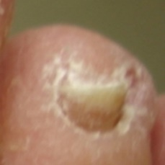fungal#41 **Confidences:**normal = 39%; fungal = 59%; warrants second opinion = 2%;   
Not very sure whether the nail is OK or not. Sorry.  
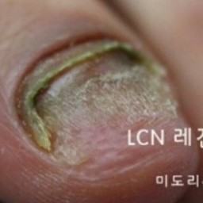fungal#53 **Confidences:**normal = 33%; fungal = 60%; warrants second opinion = 7%;   
The nail's condition is fungal with confidence score of 60%. Otherwise it is normal with confidence score of 33%.  
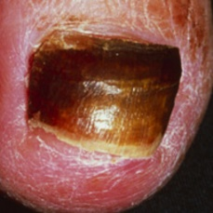fungal#18 **Confidences:**normal = 21%; fungal = 60%; warrants second opinion = 19%;   
The nail's condition is fungal with confidence score of 60%. Otherwise it is normal with confidence score of 21%.  
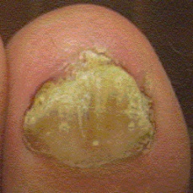fungal#28 **Confidences:**normal = 36%; fungal = 63%; warrants second opinion = 1%;   
The nail's condition is fungal with confidence score of 63%. Otherwise it is normal with confidence score of 36%.  
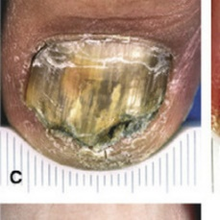fungal#20 **Confidences:**normal = 11%; fungal = 65%; warrants second opinion = 24%;   
It might be warrant a second opinion (confidence score is 24%)   
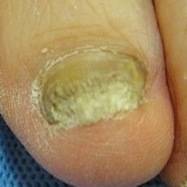fungal#42 **Confidences:**normal = 32%; fungal = 66%; warrants second opinion = 2%;   
The nail's condition is fungal with confidence score of 66%. Otherwise it is normal with confidence score of 32%.  
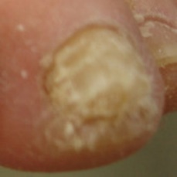fungal#40 **Confidences:**normal = 32%; fungal = 66%; warrants second opinion = 2%;   
The nail's condition is fungal with confidence score of 66%. Otherwise it is normal with confidence score of 32%.  
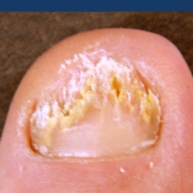fungal#10 **Confidences:**normal = 31%; fungal = 69%; warrants second opinion = 1%;   
The nail's condition is fungal with confidence score of 69%. Otherwise it is normal with confidence score of 31%.  
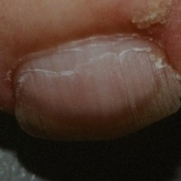fungal#9 **Confidences:**normal = 7%; fungal = 69%; warrants second opinion = 24%;   
It might be warrant a second opinion (confidence score is 24%)   
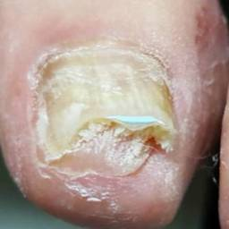fungal#43 **Confidences:**normal = 28%; fungal = 72%; warrants second opinion = 0%;   
The nail's condition is fungal with confidence score of 72%. Otherwise it is normal with confidence score of 28%.  
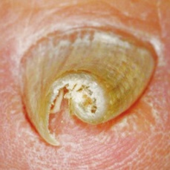fungal#35 **Confidences:**normal = 21%; fungal = 77%; warrants second opinion = 2%;   
The nail's condition is fungal with confidence score of 77%. Otherwise it is normal with confidence score of 21%.  
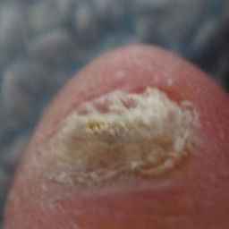fungal#39 **Confidences:**normal = 2%; fungal = 92%; warrants second opinion = 6%;   
The nail's condition is fungal with confidence score of 92%. The confidence score for it being warranting a second opinion is 6%.  
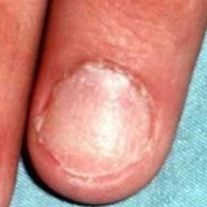warrants second opinion#42 **Confidences:**normal = 99%; fungal = 1%; warrants second opinion = 0%;   
The nail's condition is normal with confidence score of 99%. Otherwise it is fungal with confidence score of 1%.  
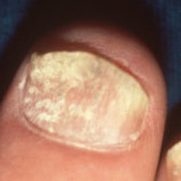warrants second opinion#40 **Confidences:**normal = 99%; fungal = 0%; warrants second opinion = 0%;   
The nail's condition is normal with confidence score of 99%.  
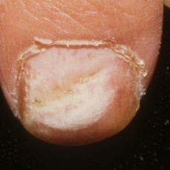warrants second opinion#13 **Confidences:**normal = 94%; fungal = 5%; warrants second opinion = 1%;   
The nail's condition is normal with confidence score of 94%. Otherwise it is fungal with confidence score of 5%.  
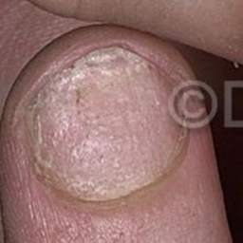warrants second opinion#35 **Confidences:**normal = 93%; fungal = 6%; warrants second opinion = 1%;   
The nail's condition is normal with confidence score of 93%. Otherwise it is fungal with confidence score of 6%.  
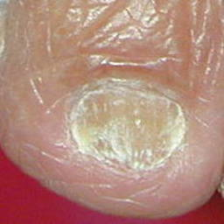warrants second opinion#24 **Confidences:**normal = 75%; fungal = 25%; warrants second opinion = 1%;   
The nail's condition is normal with confidence score of 75%. Otherwise it is fungal with confidence score of 25%.  
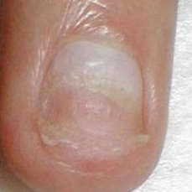warrants second opinion#31 **Confidences:**normal = 99%; fungal = 1%; warrants second opinion = 1%;   
The nail's condition is normal with confidence score of 99%. Otherwise it is fungal with confidence score of 1%.  
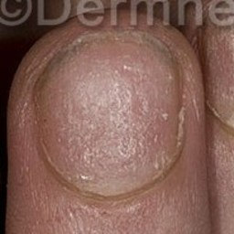warrants second opinion#33 **Confidences:**normal = 98%; fungal = 2%; warrants second opinion = 1%;   
The nail's condition is normal with confidence score of 98%. Otherwise it is fungal with confidence score of 2%.  
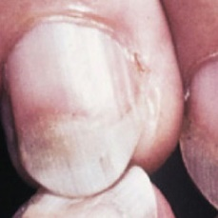warrants second opinion#14 **Confidences:**normal = 99%; fungal = 0%; warrants second opinion = 1%;   
The nail's condition is normal with confidence score of 99%. The confidence score for it being warranting a second opinion is 1%.  
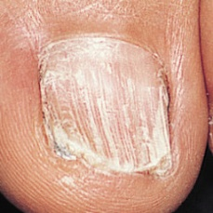warrants second opinion#34 **Confidences:**normal = 95%; fungal = 4%; warrants second opinion = 1%;   
The nail's condition is normal with confidence score of 95%. Otherwise it is fungal with confidence score of 4%.  
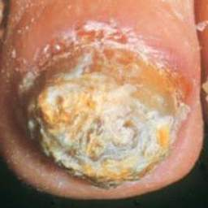warrants second opinion#38 **Confidences:**normal = 45%; fungal = 54%; warrants second opinion = 1%;   
Not very sure whether the nail is OK or not. Sorry.  
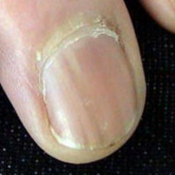warrants second opinion#6 **Confidences:**normal = 99%; fungal = 0%; warrants second opinion = 1%;   
The nail's condition is normal with confidence score of 99%. The confidence score for it being warranting a second opinion is 1%.  
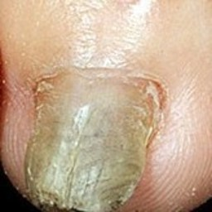warrants second opinion#21 **Confidences:**normal = 91%; fungal = 8%; warrants second opinion = 1%;   
The nail's condition is normal with confidence score of 91%. Otherwise it is fungal with confidence score of 8%.  
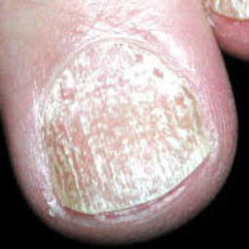warrants second opinion#46 **Confidences:**normal = 97%; fungal = 1%; warrants second opinion = 1%;   
The nail's condition is normal with confidence score of 97%. Otherwise it is fungal with confidence score of 1%.  
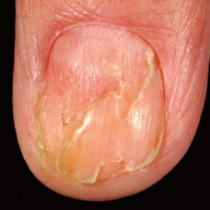warrants second opinion#41 **Confidences:**normal = 85%; fungal = 14%; warrants second opinion = 1%;   
The nail's condition is normal with confidence score of 85%. Otherwise it is fungal with confidence score of 14%.  
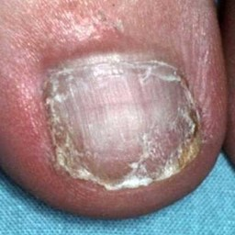warrants second opinion#49 **Confidences:**normal = 93%; fungal = 6%; warrants second opinion = 2%;   
The nail's condition is normal with confidence score of 93%. Otherwise it is fungal with confidence score of 6%.  
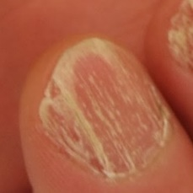warrants second opinion#16 **Confidences:**normal = 87%; fungal = 11%; warrants second opinion = 2%;   
The nail's condition is normal with confidence score of 87%. Otherwise it is fungal with confidence score of 11%.  
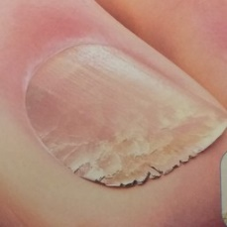warrants second opinion#29 **Confidences:**normal = 97%; fungal = 1%; warrants second opinion = 2%;   
The nail's condition is normal with confidence score of 97%. The confidence score for it being warranting a second opinion is 2%.  
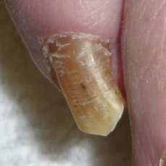warrants second opinion#48 **Confidences:**normal = 97%; fungal = 1%; warrants second opinion = 3%;   
The nail's condition is normal with confidence score of 97%. The confidence score for it being warranting a second opinion is 3%.  
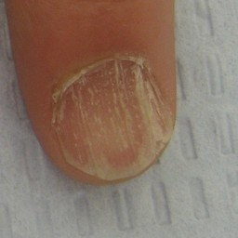warrants second opinion#44 **Confidences:**normal = 97%; fungal = 0%; warrants second opinion = 3%;   
The nail's condition is normal with confidence score of 97%. The confidence score for it being warranting a second opinion is 3%.  
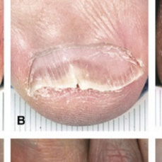warrants second opinion#28 **Confidences:**normal = 50%; fungal = 47%; warrants second opinion = 3%;   
Not very sure whether the nail is OK or not. Sorry.  
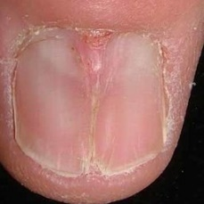warrants second opinion#36 **Confidences:**normal = 96%; fungal = 1%; warrants second opinion = 3%;   
The nail's condition is normal with confidence score of 96%. The confidence score for it being warranting a second opinion is 3%.  
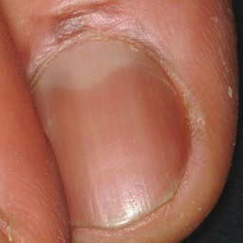warrants second opinion#3 **Confidences:**normal = 96%; fungal = 0%; warrants second opinion = 4%;   
The nail's condition is normal with confidence score of 96%. The confidence score for it being warranting a second opinion is 4%.  
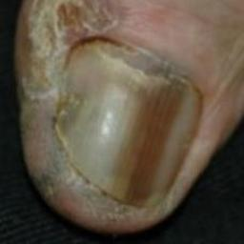warrants second opinion#7 **Confidences:**normal = 91%; fungal = 5%; warrants second opinion = 4%;   
The nail's condition is normal with confidence score of 91%. Otherwise it is fungal with confidence score of 5%.  
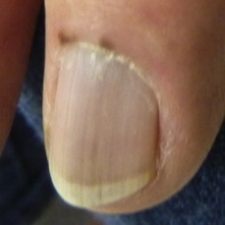warrants second opinion#4 **Confidences:**normal = 95%; fungal = 0%; warrants second opinion = 5%;   
The nail's condition is normal with confidence score of 95%. The confidence score for it being warranting a second opinion is 5%.  
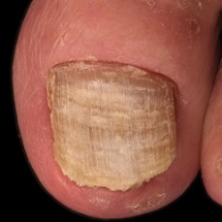warrants second opinion#25 **Confidences:**normal = 84%; fungal = 11%; warrants second opinion = 5%;   
The nail's condition is normal with confidence score of 84%. Otherwise it is fungal with confidence score of 11%.  
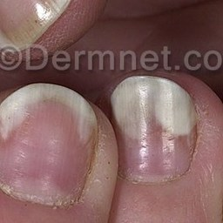warrants second opinion#23 **Confidences:**normal = 93%; fungal = 2%; warrants second opinion = 5%;   
The nail's condition is normal with confidence score of 93%. The confidence score for it being warranting a second opinion is 5%.  
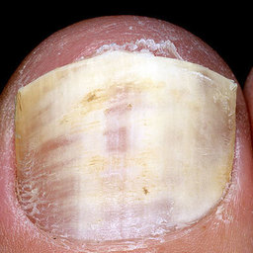warrants second opinion#30 **Confidences:**normal = 93%; fungal = 0%; warrants second opinion = 7%;   
The nail's condition is normal with confidence score of 93%. The confidence score for it being warranting a second opinion is 7%.  
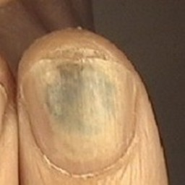warrants second opinion#22 **Confidences:**normal = 93%; fungal = 1%; warrants second opinion = 7%;   
The nail's condition is normal with confidence score of 93%. The confidence score for it being warranting a second opinion is 7%.  
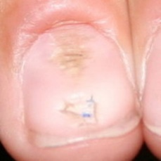warrants second opinion#15 **Confidences:**normal = 90%; fungal = 1%; warrants second opinion = 10%;   
The nail's condition is normal with confidence score of 90%. The confidence score for it being warranting a second opinion is 10%.  
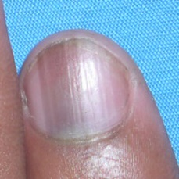warrants second opinion#0 **Confidences:**normal = 90%; fungal = 0%; warrants second opinion = 10%;   
The nail's condition is normal with confidence score of 90%. The confidence score for it being warranting a second opinion is 10%.  
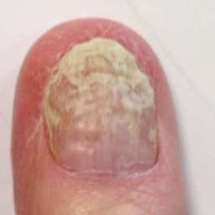warrants second opinion#17 **Confidences:**normal = 73%; fungal = 16%; warrants second opinion = 11%;   
The nail's condition is normal with confidence score of 73%. Otherwise it is fungal with confidence score of 16%.  
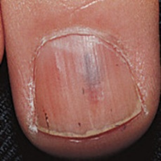warrants second opinion#47 **Confidences:**normal = 83%; fungal = 1%; warrants second opinion = 16%;   
The nail's condition is normal with confidence score of 83%. The confidence score for it being warranting a second opinion is 16%.  
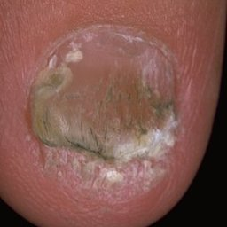warrants second opinion#20 **Confidences:**normal = 75%; fungal = 7%; warrants second opinion = 18%;   
The nail's condition is normal with confidence score of 75%. The confidence score for it being warranting a second opinion is 18%.  
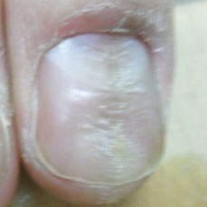warrants second opinion#45 **Confidences:**normal = 80%; fungal = 1%; warrants second opinion = 20%;   
It might be warrant a second opinion (confidence score is 20%)   
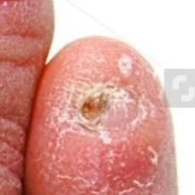warrants second opinion#26 **Confidences:**normal = 64%; fungal = 12%; warrants second opinion = 24%;   
It might be warrant a second opinion (confidence score is 24%)   
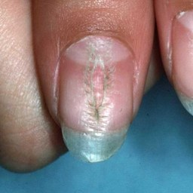warrants second opinion#39 **Confidences:**normal = 71%; fungal = 4%; warrants second opinion = 25%;   
It might be warrant a second opinion (confidence score is 25%)   
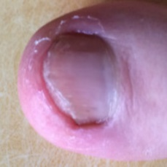warrants second opinion#10 **Confidences:**normal = 74%; fungal = 0%; warrants second opinion = 26%;   
It might be warrant a second opinion (confidence score is 26%)   
warrants second opinion#11 **Confidences:**normal = 74%; fungal = 0%; warrants second opinion = 26%;   
It might be warrant a second opinion (confidence score is 26%)   
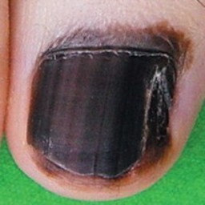warrants second opinion#9 **Confidences:**normal = 71%; fungal = 2%; warrants second opinion = 28%;   
It might be warrant a second opinion (confidence score is 28%)   
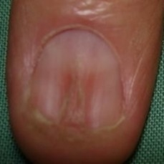warrants second opinion#43 **Confidences:**normal = 65%; fungal = 5%; warrants second opinion = 30%;   
It might be warrant a second opinion (confidence score is 30%)   
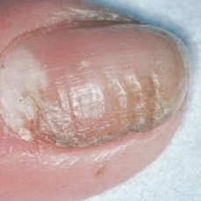warrants second opinion#37 **Confidences:**normal = 60%; fungal = 4%; warrants second opinion = 36%;   
It might be warrant a second opinion (confidence score is 36%)   
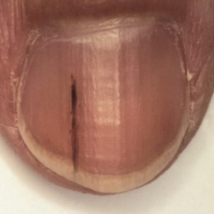warrants second opinion#5 **Confidences:**normal = 63%; fungal = 0%; warrants second opinion = 37%;   
It might be warrant a second opinion (confidence score is 37%)   
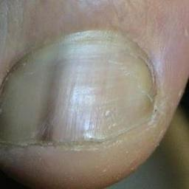warrants second opinion#8 **Confidences:**normal = 62%; fungal = 0%; warrants second opinion = 38%;   
It might be warrant a second opinion (confidence score is 38%)   
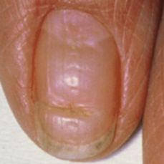warrants second opinion#27 **Confidences:**normal = 60%; fungal = 1%; warrants second opinion = 39%;   
It might be warrant a second opinion (confidence score is 39%)   
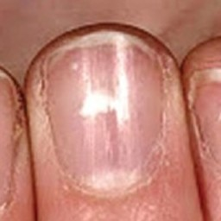warrants second opinion#19 **Confidences:**normal = 54%; fungal = 1%; warrants second opinion = 45%;   
Not very sure whether the nail is OK or not. Sorry.  
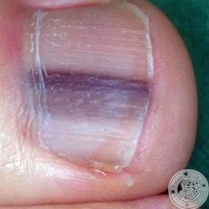warrants second opinion#2 **Confidences:**normal = 42%; fungal = 1%; warrants second opinion = 58%;   
Not very sure whether the nail is OK or not. Sorry.  
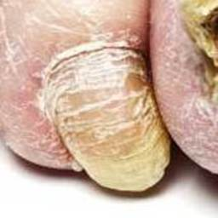warrants second opinion#32 **Confidences:**normal = 33%; fungal = 7%; warrants second opinion = 59%;   
Not very sure whether the nail is OK or not. Sorry.  
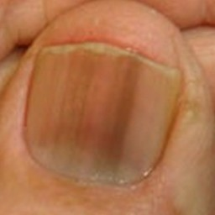warrants second opinion#1 **Confidences:**normal = 37%; fungal = 0%; warrants second opinion = 62%;   
It is most likely that the nail indicates something that warrants a second opinion and you should seek medical advice. (Confidence score is 62%)  
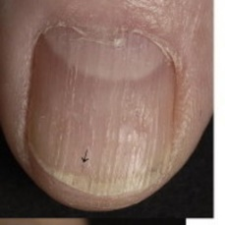warrants second opinion#18 **Confidences:**normal = 33%; fungal = 1%; warrants second opinion = 66%;   
It is most likely that the nail indicates something that warrants a second opinion and you should seek medical advice. (Confidence score is 66%)  
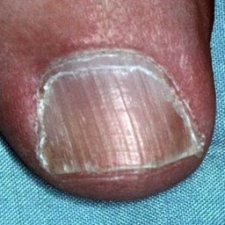warrants second opinion#12 **Confidences:**normal = 31%; fungal = 1%; warrants second opinion = 68%;   
It is most likely that the nail indicates something that warrants a second opinion and you should seek medical advice. (Confidence score is 68%)